**Chapter 2**

**Case Study - Spatial Analysis of Deer Island**

**Introduction and Background**

Coastal shorelines are naturally dynamic systems that transform over different spatial and temporal scales because of oceanographic and geomorphic processes (Davina et al., 2016). Climate change is predicted to cause an immediate effect on coastal shorelines due to submergence and increased flooding of coastal land due to sea-level rise (Nicholls and Cazenave, 2010). Long-term effects will also occur on coastal shorelines, as sea-level changes such as increased shoreline erosion and saltwater intrusion into groundwater will negatively impact vegetation (Nicholls and Cazenave, 2010) and people who depend on groundwater for water supply (Saetta et al., 2015). Increased sea-level rise, due to climate change, can potentially increase the frequency of intense storm events (e.g hurricanes) (Johnson et al., 2015), which contribute to a surge in physical wave climates on shorelines. These environmental factors can lead to an increase rate of shoreline change.

*Shoreline retreat due to sea-level rise*

Coastal retreats are the landward displacement of a shoreline due to marine erosion or flooding (Bird, 1993). Shoreline retreats are linked to coastal submergence and increased flooding because of relative sea-level changes (Cazenave and Cozannet, 2014). Many studies have found that coastal erosion is more likely when sea-level rise is rising faster. Along the eastern coast of the United States, a relationship between coastal shoreline changes and increased rates of sea-level rise has been documented (Zhnag et al., 2004). Kirwan and Megonigal (2013) document that tidal wetland conversion to open water through sea-level rise is expected to accelerate, with prediction of 20-45% loss of salt marsh during the current century. The implication of increasing rates of sea-level rise are that shorelines will become inundated more frequently causing shorelines to erode repeatedly, which can have cause impacts to developed and undeveloped shorelines. As an example, increased erosion and loss of shorelines could reduce the shoreline habitat available for shorebird nesting and foraging (Aiello‐Lammens et al., 2011).

The impact of sea-level rise presents a tidal flooding problem along low-gradient shorelines. Low elevated marsh shorelines are being converted to open water in the Gulf of Mexico (Kirwan and Megonigal, 2013). Progressive inundation reduces organic matter contributions from vegetation and accelerates erosion, causing a feedback that fast-tracks erosion (Morris et al., 2002). In the Big Bend region of Florida, Raabe and Stumpf (2015), documented that mean higher high water (MHHW) had increased from 1 m to 1.2 m (Figure 1) at Cedar Key, Florida during the tide gage record from 1941 to 2011. The effect of sea-level rise on Florida’s Big Bend shoreline has been less obvious because of the of limited causal observations of tidal flooding and changes occurring due to lack of development along the coast (Raabe and Stumpf, 2015). Implications of unnoticed sea-level rise in this region could mean loss of intertidal marshes and 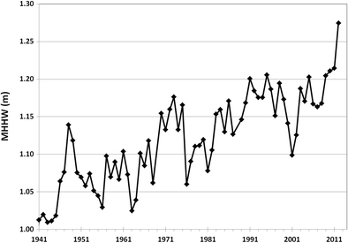disappearance of small shore islands, due to increased erosion.

Figure 1 - Average mean higher high water (MHHW) at Cedar Key, FL, 1941–2011, showing approximately 0.2 m increase over 70 years (NOAA [2014](https://link.springer.com/article/10.1007/s12237-015-9974-y#CR43), (Raabe and Stumpf, 2015),( https://tidesandcurrents.noaa.gov/sltrends/sltrends_station.shtml?id=8727520)

*Saltwater intrusion and vegetation*

Saltwater intrusion on coastal wetlands causes vegetation mortality from persistent shoreline submergence or high salinities, and the transition of coastal saltwater habitats to open water (Kaplan, Wan, and Roberts, 2010). Flynn et al. (1995) conducted a simulated saltwater intrusion experiment on a freshwater marsh vegetation and documented that vegetation regrowth recovery could occur but were strongly influenced by post-intrusion salinity and water levels. Vegetation recovery could be expected due to low water levels and salinity, after a saltwater intrusion event. Increased saltwater intrusion will also decrease the survival of young trees and seedlings (Langston et al., 2017). The ability for vegetation to have the opportunity to recover from saltwater intrusions is significantly decreased due to sea-level rise and the frequency of storm events.

A study by Raabe (1997) used Landsat Thematic Mapper (TM) imagery from 1986 to 1995 and evaluated the imagery for signs of vegetation change in the Big Bend region of Florida. Raabe (1997) documented observable differences in vegetation with increases and decreases in vegetation indexes along the Big Bend coastline. The changes that Raabe (1997) observed indicate that vegetation index changes at the Gulf of Mexico shoreline could be attributed to sea-level rise, which is also an indicator of shifting vegetation index green biomass at the gulf edge.

*Hurricane impacts and sedimentation*

Climate change is impacting coastal shorelines by increasing the frequency of cyclones and hurricanes due to the recent rise of greenhouse warming, with an intensity increase of 2-11% in the next 100 years (Knutson et al., 2010). Lewsey (2004) explains how islands are impacted by climate change with such environmental factors such as varying yearly rainfall, frequency and intensity of hurricanes, and patterns of wave action. Frequency of storm surges and wave action will also intensify infrastructure vulnerability of shorelines (Lewsey et al., 2004) and lead to shoreline erosion. Mudd et al. (2014) also suggests that past observational studies have found that substantial increases in the frequency of tropical cyclones generated in the Atlantic basin are attributed to an increase in sea-surface temperature due to climate change.

Despite strong storm events causing physical damage to shorelines, one benefit to these same shorelines could occur. Some studies suggest that storm effects on coast environmental have shown high-energy storm events often rework a shoreline through various erosional and depositional processes (Hayes 1963; Komar 1983). Storms can have positive impact along the Gulf of Mexico coast by redistributing sediment and helping to maintain marsh-surface elevation. The Big Bend coastline is a “low energy” shoreline, which can benefit from these high-energy storm events (e.g. hurricanes) (Goodbred and Hine, 1995). On March 1993, the extratropical “Storm of the Century” resulted in the deposition of storm- suspended sediments along Florida’s west- central coast. The result of the deposition added ~ 10-years’ worth of average accretion, suggesting that storm-driven transference could be an effective method of sediment deposition along coastlines (Goodbred and Hine, 1995). This study also suggests that typical episodic storm events could have the greatest benefit to shorelines, but it is unclear if the increased frequency of storm events, due to climate change, will add the same sedimentation benefit or lead to a negative effect on the coastline.

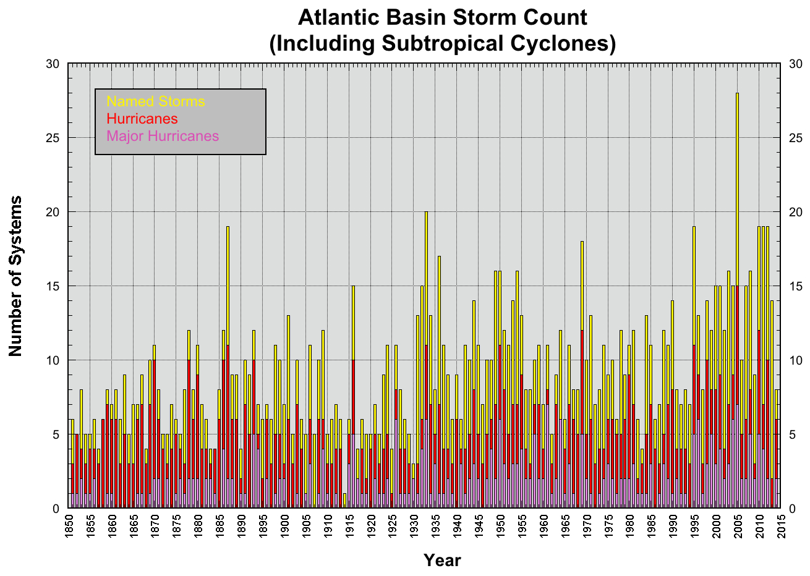 Figure 2 –Bars depict number of named systems (yellow), hurricanes (red), and category 3 or greater (purple), 1850-2014 (<https://www.nhc.noaa.gov/climo/>).

*Human impacts adding to shoreline decline and its effects on species*

Florida is a hotspot of endemism for biodiversity (Noss et al., 2013). Much of the biodiversity are threatened by the increase of urbanization and environmental coastal degradation (Finkl and Charlier, 2003). Florida is the fourth most populous state in the US and the third fastest growing state (US Census 2010). The Big Bend Florida coastline is one of Florida’s most rural and remote areas, where most of the local economy is dominated by timber, agriculture, commercial/recreational fishing, and tourism (Kautz, Gilbert, and Stys, 1999). The Florida counties that make up the Big Bend are Dixie, Levy, and Taylor, which are projected to increase by 2045 as depicted in Figure 3 (<https://www.bebr.ufl.edu/population>). With most of the Big Bend coastal land underdeveloped, currently, it could be likely in the future that businesses and people will want to develop housing along the shoreline. Results of human development can include accelerated coastal erosion as well (Finkl and Charlier, 2003). Combine with sea-level rise, the rate of shoreline decline could be increased.

More people along the coastal regions usual means more development leaving habitats for animals and plants are at greater risk of extinction.

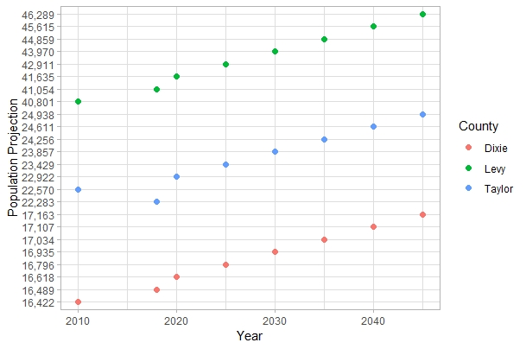

Figure 3- Generated figure based on census and projection data from <https://www.bebr.ufl.edu/population>.

-Impacts to humans

- loss of area that could be utilized to fish, hunt, live, use as recreation

-Impacts to wildlife

- loss of habitat for native/ migrating species that hunt/fish that live in the habitat

-Impacts to potential protection to mainland

-less protection from storm surges

- more damage to protected areas, will be harder to restore protected areas

*Restoration Efforts*

Restoration efforts in coastal zones may be strongly influenced by landscape level processes. The Gulf of Mexico coastline, with its low relief geomorphology, especially in Florida, is also vulnerable to coastal erosion (Geselbracht et al., 2011). Much of the Florida coastline consists of a 1-meter elevation contour that extends inward anywhere from 3 to 10 kilometers. This low elevation leaves the Florida coastline susceptible to frequent coastal changes. Other types of landscape changes occur at different time scales and may have different (and unknown) effects including conversion from wetlands to shallow shores.

The Big Bend coastline is 60 miles west of Gainesville Florida and is located in the Gulf of Mexico. The Big Bend is largely undeveloped, which is usual considering that most of the Gulf of Mexico coastline is mainly developed. Around 30% of the Big Bend land area and over 60 miles of coastline are under conservation protection (Main & Allen 2007). Human population density around the Big Bend is the lowest of any other coastal Florida city and the percentage of intact natural habitat is considerably high (Geselbracht 2007). Due to, in part, low human densities, coastal areas have not been heavily impacted by boat traffic, dredging, heavy industrial pollution, eutrophication, or other anthropogenic impacts (Seavey et al. 2011). Despite the lack of human influence, many observable declines in ecosystem and habitats have been documented (Seavey et al. 2011).

In this chapter I will develop a data workflow and conduct a geospatial analysis to assess trends on a specific region of the Big Bend. Analyzing trends of landscape level change over time can provide basic information on how systems may be changing. These quantified trends can motivate actions to improve management and protection of coastal and inland habitats.

Observations of island shoreline change

Deer Island is an island that can provide relief from storm events and storm surges. Briefly comparing imagery from 1984 to 2018, it can be observed that there are some shape changes to the island. Unlike Derrick Key, Deer Island is still visible and still available for use by people and habitat use by animals. Between the 34 years, between the imagery, there are some observable shoreline differences but not nearly as drastic as the shoreline differences of Derrick Key.

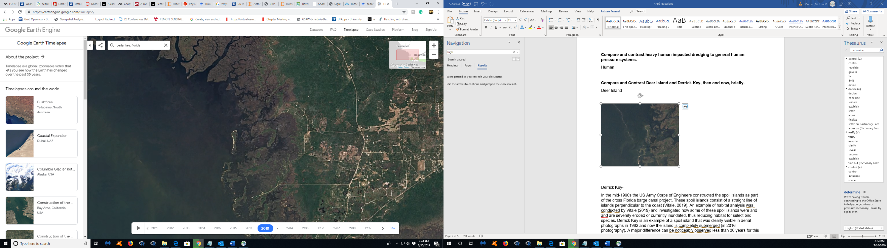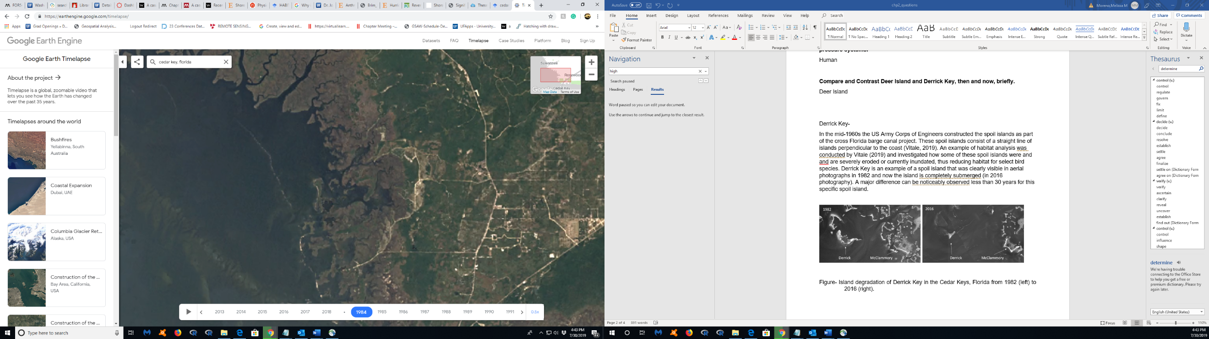

Figure- Google Earth Engine imagery of Deer Island, from 1984 (left) to 2018 (right).

Derrick Key

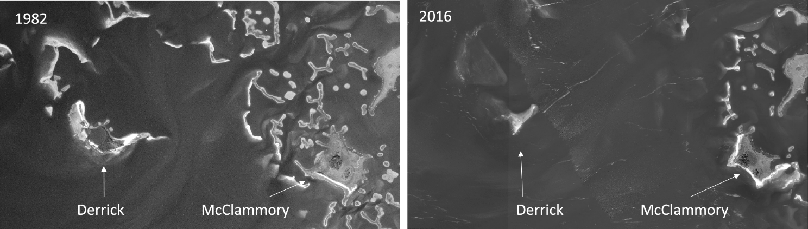In the mid-1960s the US Army Corps of Engineers constructed the spoil islands as part of the cross Florida barge canal project. These spoil islands consist of a straight line of islands perpendicular to the coast (Vitale, 2019). An example of habitat analysis was conducted by Vitale (2019) and investigated how some of these spoil islands were and and are severely eroded or currently inundated, thus reducing habitat for animals. Derrick Key is an example of a spoil island that was clearly visible in aerial photographs in 1982 and now the island is completely submerged (in 2016 photography). Major shoreline differences are noticeably observed in the 34 years, time between the imagery, for this specific spoil island.

Figure- Island degradation of Derrick Key in the Cedar Keys, Florida from 1982 (left) to 2016 (right), (Vitale, 2019).

**Reason for Research**

Because of how little the Big Bend coastline has been influenced by outside forces, there is a high interest to protect the coastal areas that have not been colonized. There are several restorative and conservation projects in the Big Bend, which are funded through National Fish and Wildlife Foundation (NFWF), who have been allocating money from the 2010 Deepwater Horizon oil spill as of 2013 (https://www.nfwf.org/gulf). The agreement of the settlement is directed to fund projects benefitting the natural resources of the Gulf Coast that may have been impacted by the spill. The awards are invested into projects to conserve and enhance coastal habitats. The Lone Cabbage Restoration project (LCR) is a program funded through NWFW to restore and monitor oyster populations. The LCR project has been working with other agencies such as Florida Fish and Wildlife Conservation Commission (FWC) and Nature Coast Biological Station (NCBS) to unify available biological data including water quality and species density monitoring. These biological data are important to illustrate a larger picture of the natural impacts that have occurred in the Big Bend.

Spatial analysis in the Big Bend is a monitoring evaluation that has not been fully explored, despite large conservation interest in the area. An example of spatial analysis efforts can been seen in Raabe (2004), who digitized information from surveys of the coastline, from approximately the Suwannee River mouth to Tampa Bay, and collected topographic sheets from the 1800’s and compared these surveys to available satellite imagery from 1995 to characterize changes in coastal habitats between these two time periods. Research such as Raabe (2004) are useful because they provide resource managers with long-term perspective on how resources are or are not changing. Examining these trends will provide necessary information to the efforts in the area to , including the LCR project.

**Objectives**

Review all available mapping imagery and materials of the Big Bend coast and Suwannee Sound to A) organize and store the materials for future conservation projects as per USGS data management standards, B) conduct a geospatial analysis on coastal changes, gained and/or lost, from the earliest appropriate mapping data of Deer Island C) outline methods of geospatial analysis for future use and analyses of the LCR project for maximum reproducibility.

**Study Area – Deer Island**

The research area for this case study will be Deer Island, which is off the coast of the Big Bend Florida in Suwannee Sound, which is in the Gulf of Mexico. The area of study that will be analyzed is the coastline of Deer Island. Deer Island is a barrier island consisting of 90 acres in total area, which comprises of 25 acres of upland habitat and 20 acres of wetland habitat. The island coastline features a sandy beach facing the open Gulf of Mexico. Deer island is not inhabited, but there are some man-made structures from the late 1800s. Deer Island is located 8 miles north of Cedar Key, Florida. The surrounding islands around Deer Island will be observed for changes but will not be quantified.

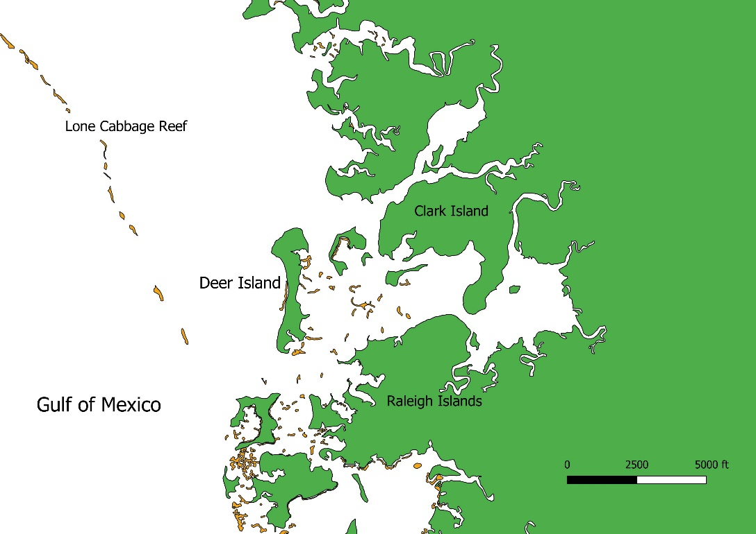

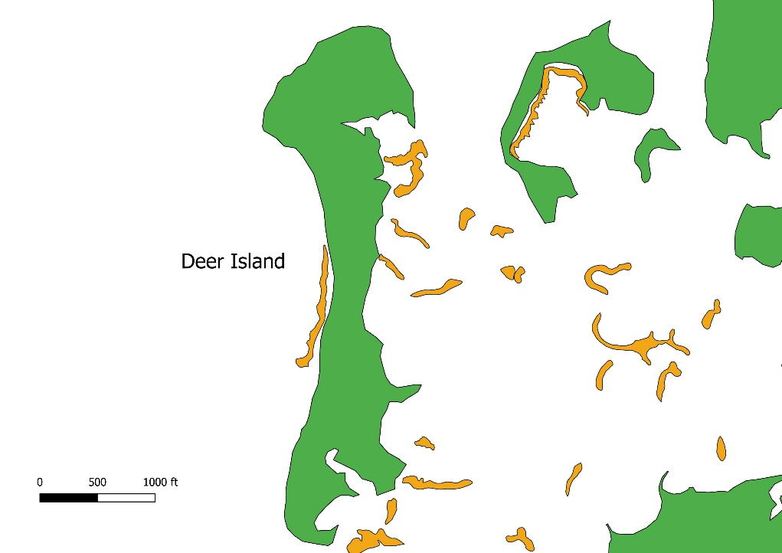Figure 1- Zoomed out view of study area, Deer Island, for spatial context in relation to Lone Cabbage Reef. Land mass is colored in green, and oyster clusters are colored in orange.

Figure 2- Zoomed in view of study area, Deer Island. Land mass is colored in green, and oyster clusters are colored in orange.

**Methods**

*Indicators*

A shoreline change indicator includes high water line (HWL) and vegetation (Boak et al., 2005). High water line is the most common indicator, and it can be defined as a visually determined change in tone left by the maximum runup from a preceding high time (Anders and Byrnes, 1991). HWL can normally be established through aerial photographs, which could be obvious to spot a debris line or a static shoreline parallel line (Crowell, Leatherman, and Buckley, 1991). Because HWL observations can vary wildly between studies, I will propose an HWL definition specifically related to Deer Island that will consider what factors are available in the imagery to determine what constitutes an HWL. Derek key is currently inundated, but a similar HWL definition will be applied to earlier available imagery.

Defined methods for this case study are not solidified. Many software programs and packages are available through the University of Florida and open source resources. There are general methods and techniques that will be mentioned in this section.

*Organization and Storage*

USGS Data Management standards explain that some of the best practices for processing spatial data are to use open formats such as geoTIFF and use open-source solutions whenever possible. The manual also describes that adding metadata to datasets to define the who, what, where, when, why, and how is important so that data can be understood, re-used, and integrated with other datasets. In the Geological Survey Manual section SM 502.7 states:

“metadata must accompany all USGS scientific data and other information products. Metadata records are to be developed in a standardized way that enables users to understand the context and to evaluate the usefulness of the data or information product. Metadata records for scientific data must comply with standards such as the FGDC Content Standard for Digital Geospatial Metadata, the International Organization for Standardization suite of standards, or other USGS endorsed FCDC standards. A minimum of one metadata review by a qualified reviewer is required for all USGS scientific data and other information products approved for release.”

Some metadata software recommended by USGS are USGS Metadata Wizard (<https://www.sciencebase.gov/catalog/item/50ed7aa4e4b0438b00db080a>) and USDA Metavist (<https://www.nrs.fs.fed.us/pubs/2737>). These software allow to the user to create FDGC (Federal Geographic Data Committee) Metadata for geospatial datasets. USGS is pushing to have these metadata to be incorporated in published geospatial datasets to standardize ways groups are storing and recording their geospatial data sets.

As far as my graduate research analysis, I will be using the T:Drive storage of the LCR project to store my datasets. I will use practices to store and backup my geospatial datasets as per USGS Data Management standards. These details will be finalized during imagery processing and analysis. Completed analysis and geospatial datasets will be located in GitHub, a version control online software, for easability to download and reproduce.

*Geospatial Analysis*

*Documenting Workflow*

As in Chapter 1, it will be important to document the workflow of a complete and accurate product. Having a completed analysis of Deer Island with the available mapping data will be available for any biologist interested in the Big Bend area at the end of my graduate research. As previously mentioned, the Big Bend is an area of interest for many conservation groups and projects, so it is imperative to document the workflow in an easy and reproducible way that is approachable to many people with many different skill sets.

The USGS Data Management best practices for sharing data are to 1) document the process thoroughly 2) create an easy to find data storage and 3) putting the information “out there” for people to locate. Objective A, of my proposed graduate research, covers practices 2 and 3 of the USGS Data Management best practices, and Objective C covers practice 1. The recommendations for sharing datasets are to clearly define the purpose of the research, describe attributes and geography, include associated links, specify a required data citation and acknowledgements, and create a second public version containing all appropriate metadata.

Workflow documentation will contain step by step guide, screen shots, and descriptive text. Final documentation will be pushed to Github in a .doc or .pdf format.

Hicks, S. D., Debaugh, H. A., Jr., and Hickman, L. E., 1983, Sea level variations for the United States, 1855–1980: Rockville, Maryland, Na-tional Ocean Survey, 170 p.

Komar, P. D., 1983, Handbook on coastal processes and erosion: Boca Ra-ton, Florida, CRC Press, 305 p.